EECS5411 HW3

1. It is possible to achieve a summed squared parameter error of 0.0005 or less within 1000

samples from a cold start by selecting mu = 0.08, which is shown in Matlab L9_1a.m.

The final answer of if the error is larger than 0.0005 is

ans =

logical

0

Therefore, it is possible. Below are the plot of w,v, sspe, and frequency response of the original system F and recover system G. 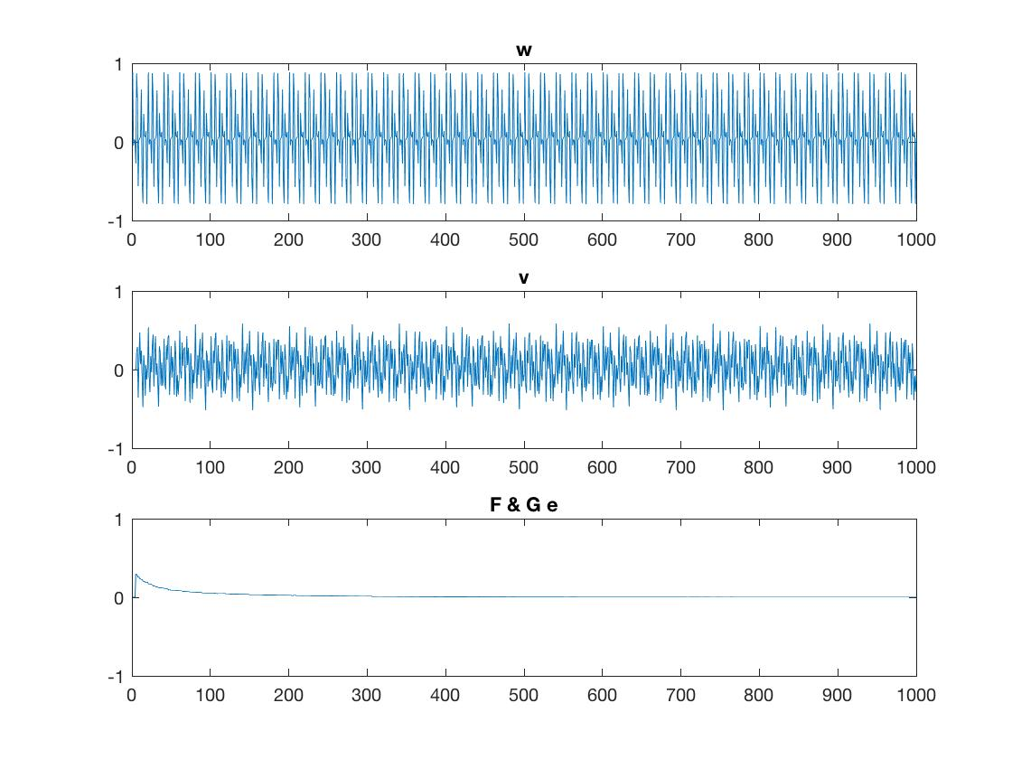

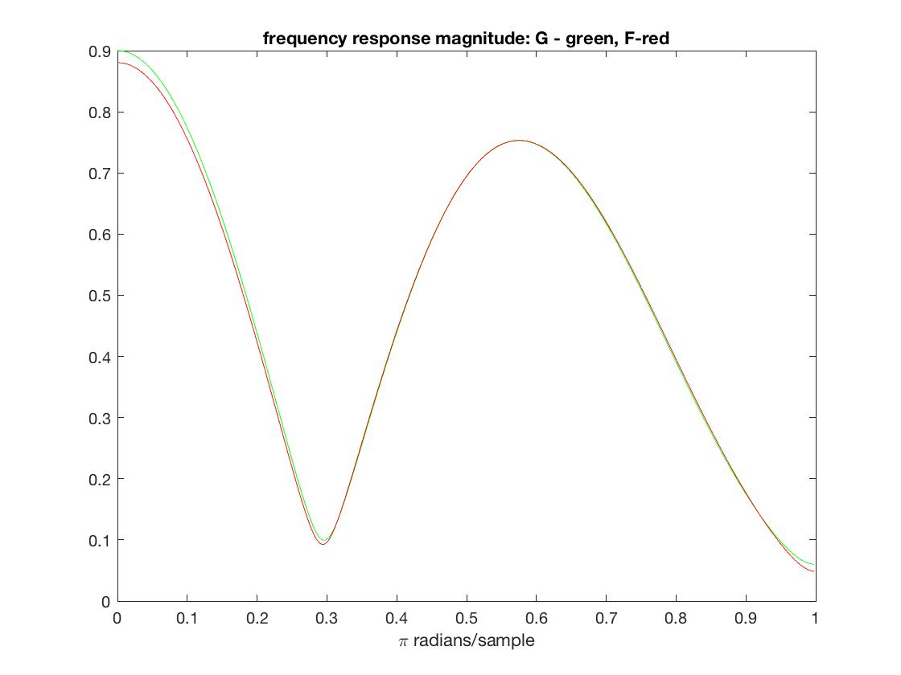

1. L9_2.m

In the Matlab code, a song is imported and sampled, and then is added with filtered white noise that makes it unclear. First the program plays the noisy song, then processes the signal with a noise canceller using LMS from a cold start.

After any key is pressed, the program will play another noisy song that has been processed by LMS that only uses the first one-third part of the signal.

After any key is pressed, the program will play the third noisy song that has been processed by LMS that uses the two-third parts of the signal.

In the end, the program will play the song that has been recovered by full LMS.

The program also plot the noise, recovery signal and the filter frequency response of 3 LMS processes. They can show the process of the noise is cancelled step by step, and the recovery filter is getting closer to the original one.

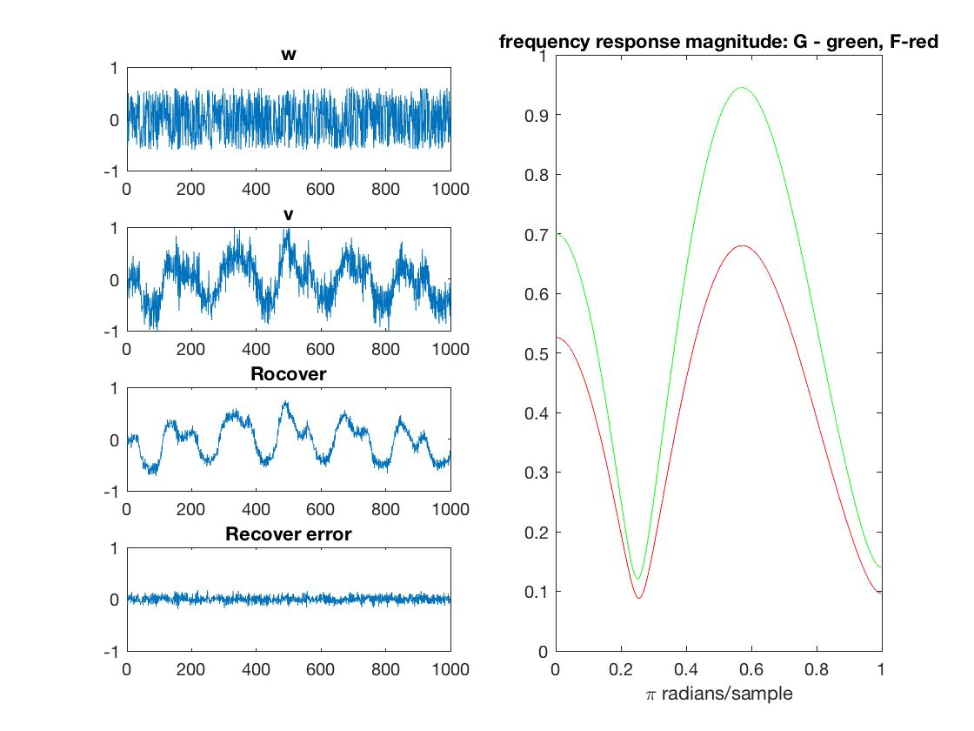

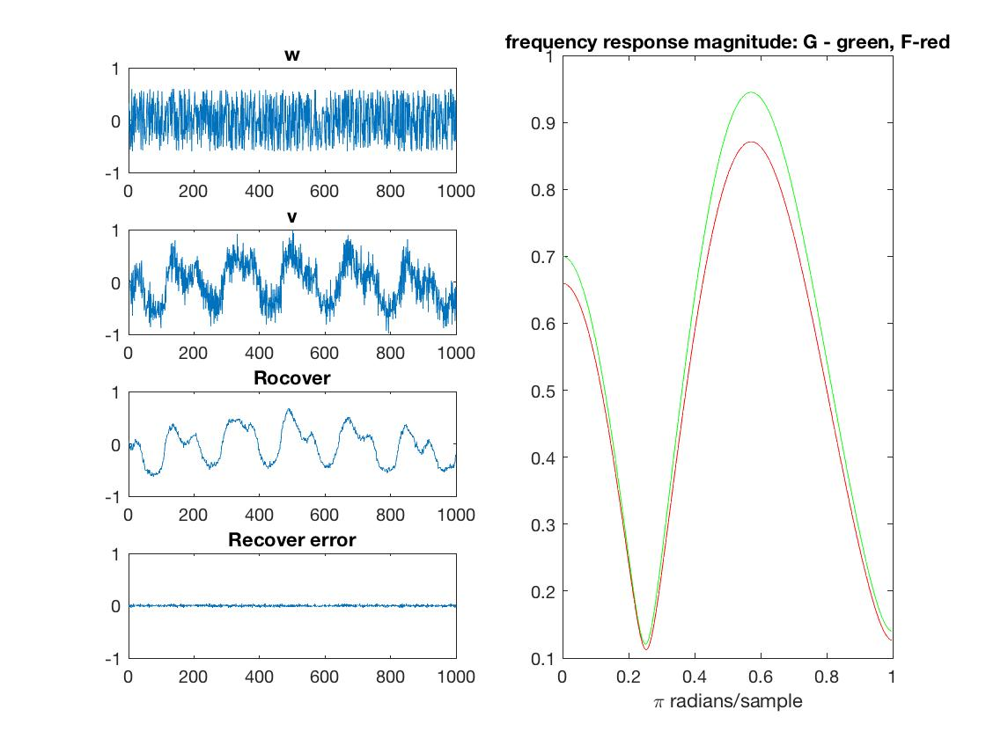

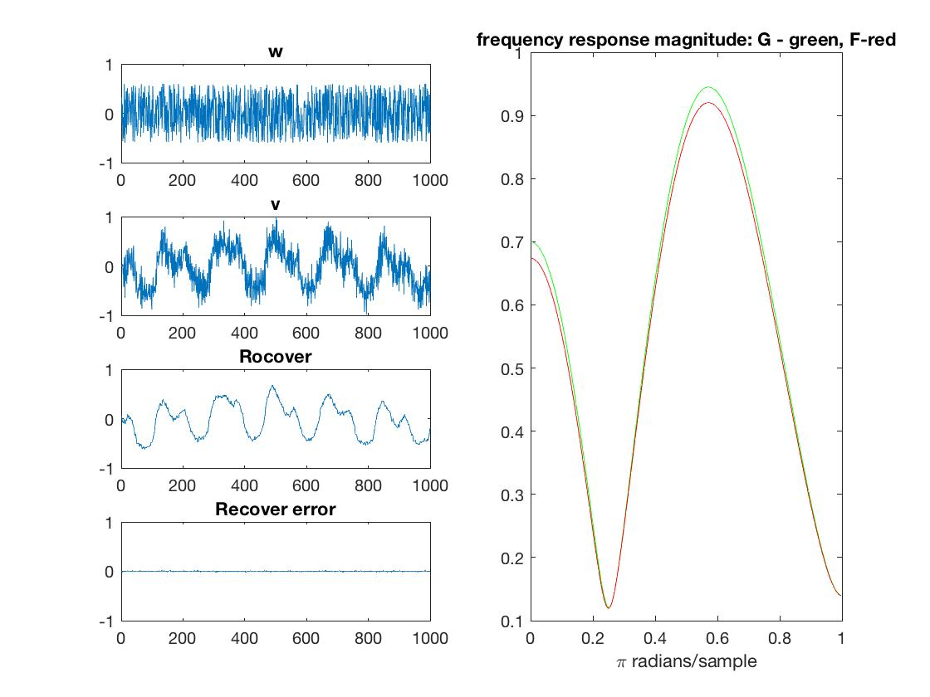

1. L10_1

(a)An MMSE equalizer of length 35 is computed in Mathematia. The optimal delay is 35.

Then a 3D plot of the optimal delay with regards to lemda and rou is ploted. We can see as lemda or rou has significant increase or decrease, the optimal delay will change.

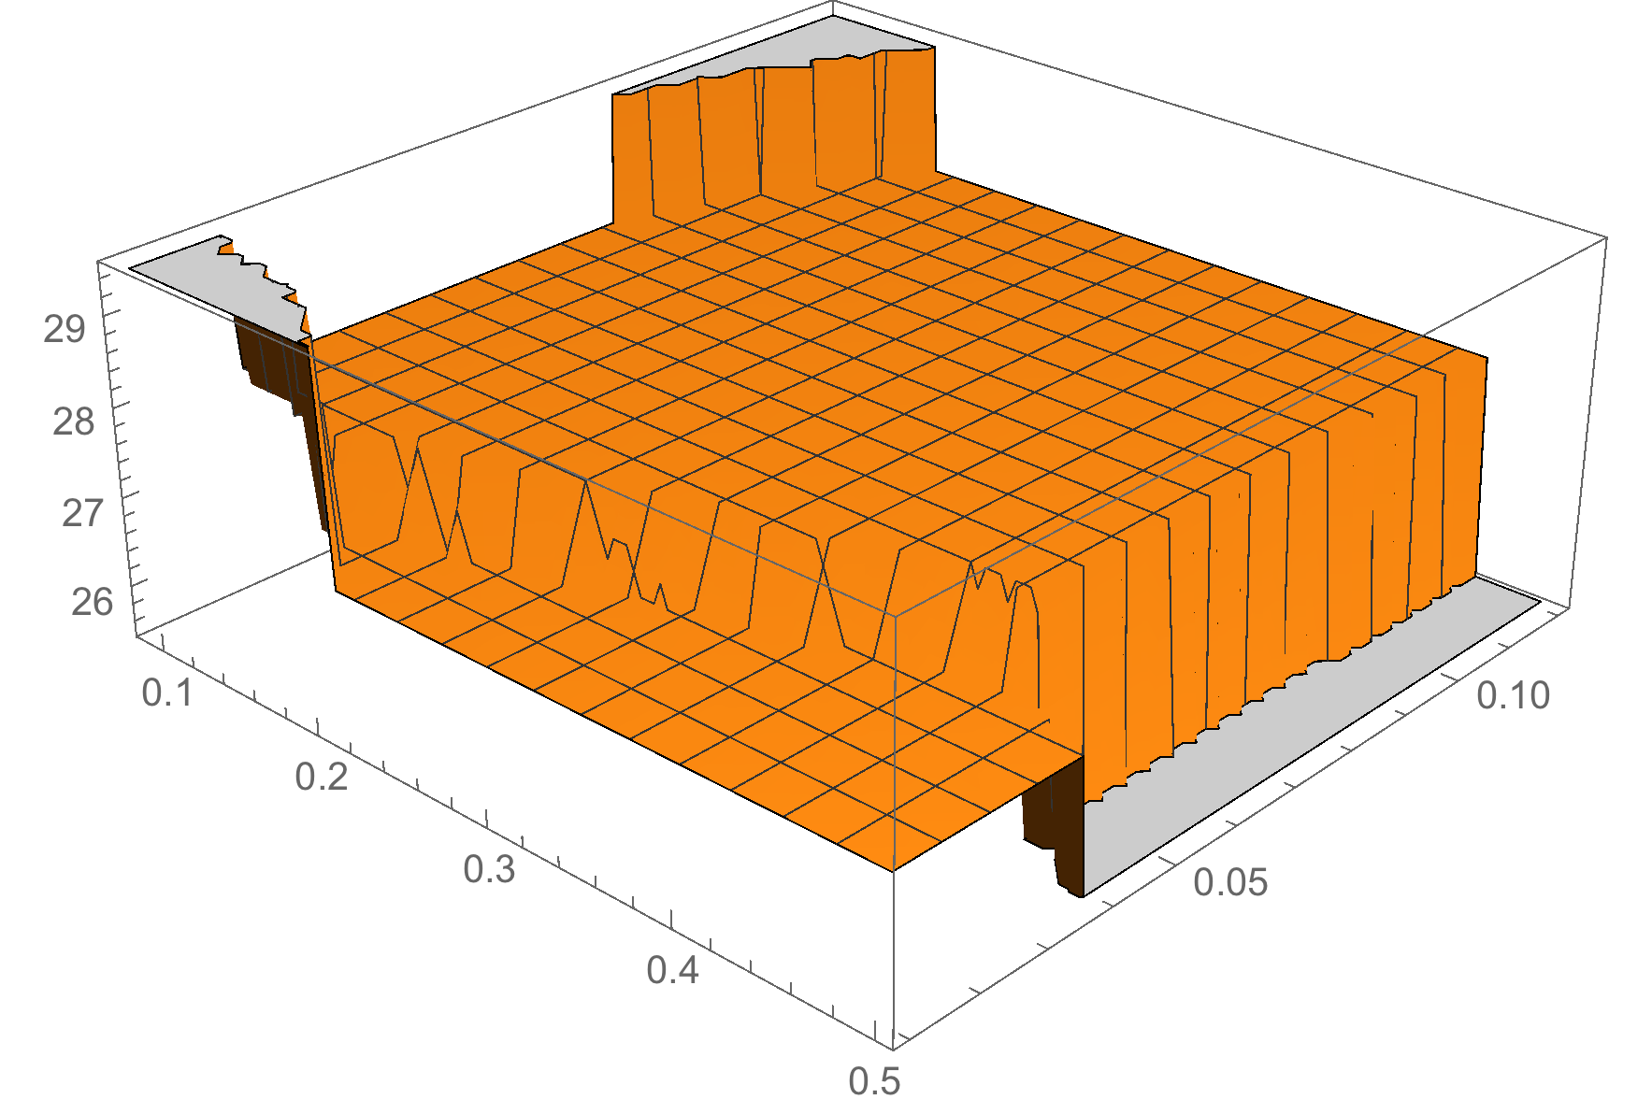

(b) The simulated behavior for a 4-level (±1, ±3) source signal in terms of the percentage of decision errors of 3.71%, the equalizer’s frequency response, and the combined equalizer’s instantaneous impulse response are shown below. The output of decision achieves relatively low error rate. And the eye-opening of frequency response is achieved, except there are some small mismatches.

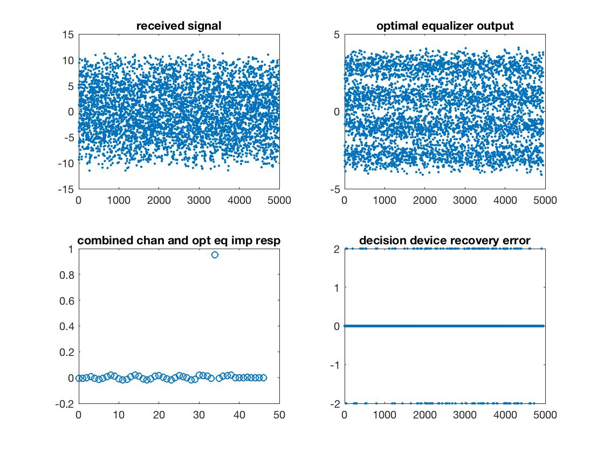

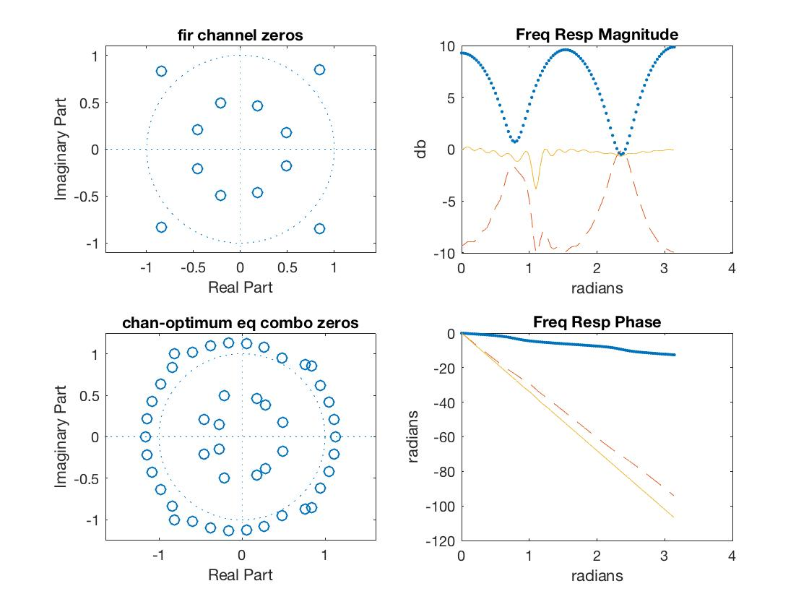

As the length of equalizer increases, the error rate drops. When length is 80, the error rate is around 2%. When the length increases to 800, the error rate drops to 0.5%.

1. L10_2x.m

The achieved mean squared prediction error for the MMSE equalizer of length 20, 35, 50,65 and 80 for all possible delays. Also, the ranges of the delay values for which the asymptotic system performance (confirmed by simulation) is no more than twice that achieved with the optimal delay are computed and plotted.

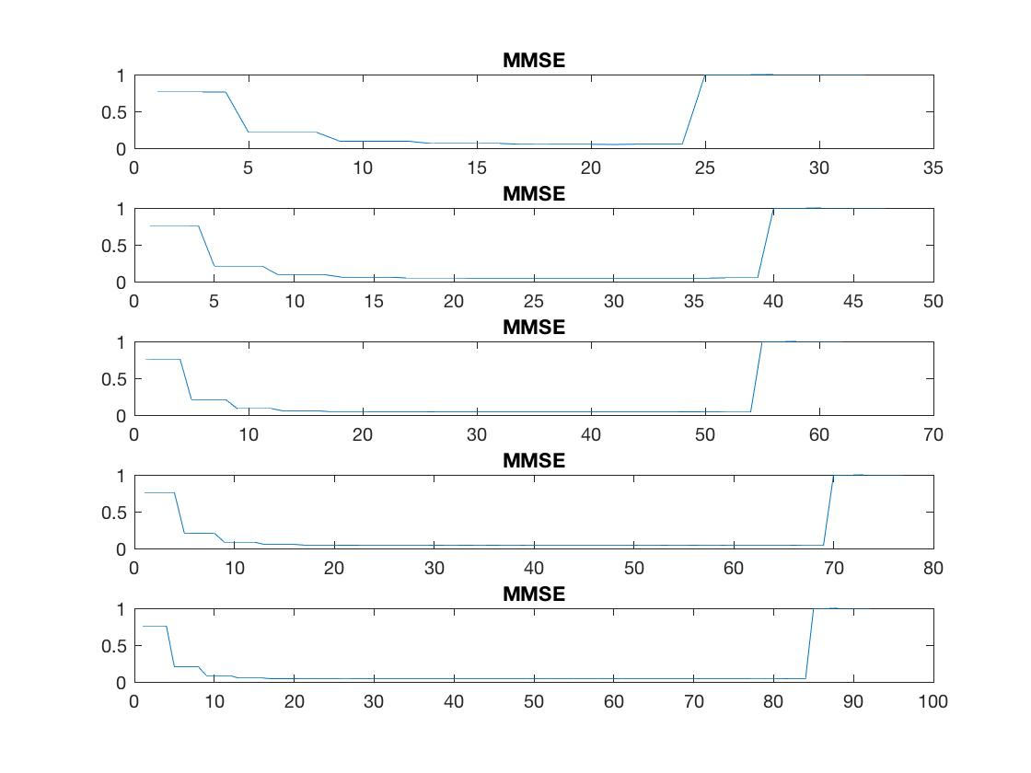

As the length of the equalizer is increased this range of satisfactory delay selection is expected to get wider. But the relative range would decrease a little bit in the length of 65.

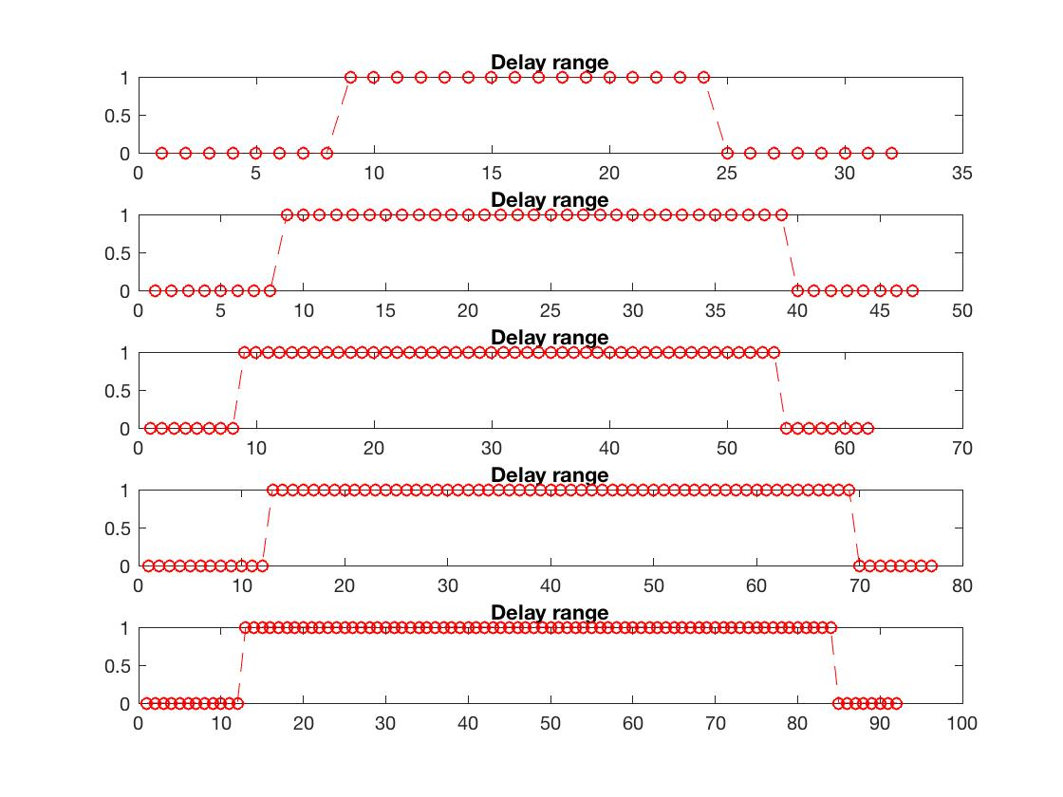

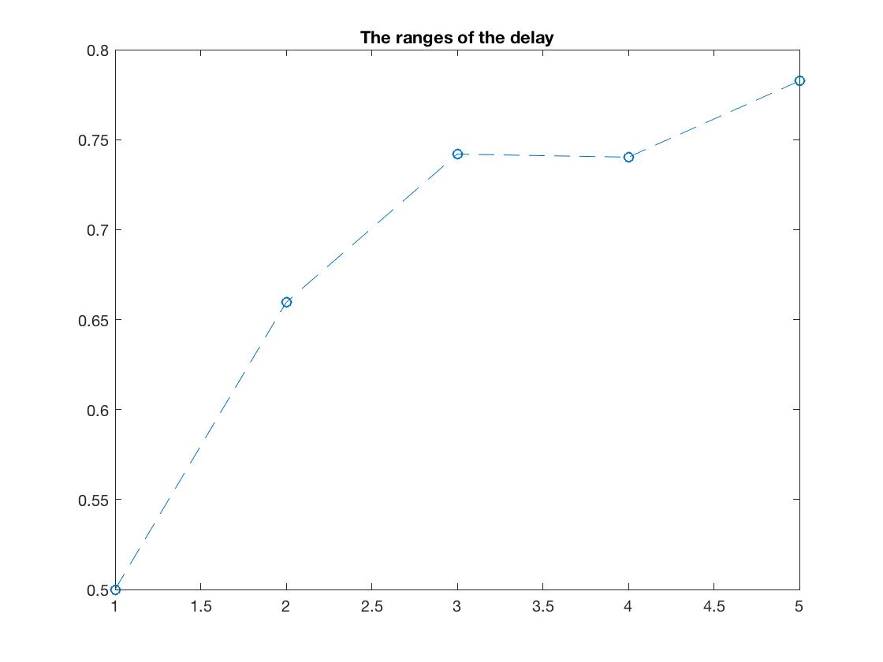

1. L11_1

A baud-spaced equalizer is simulated using LMS with training and the convergence (of the average of the adapted parameters) to the MMSE solution is verified.

We can see the sspe is dropping during the training process and the adapted parameters converge to the MMSE solution.

The prediction error is high, about 27% for 4-PAM input, but it is low at bpsk input, 1.05%.

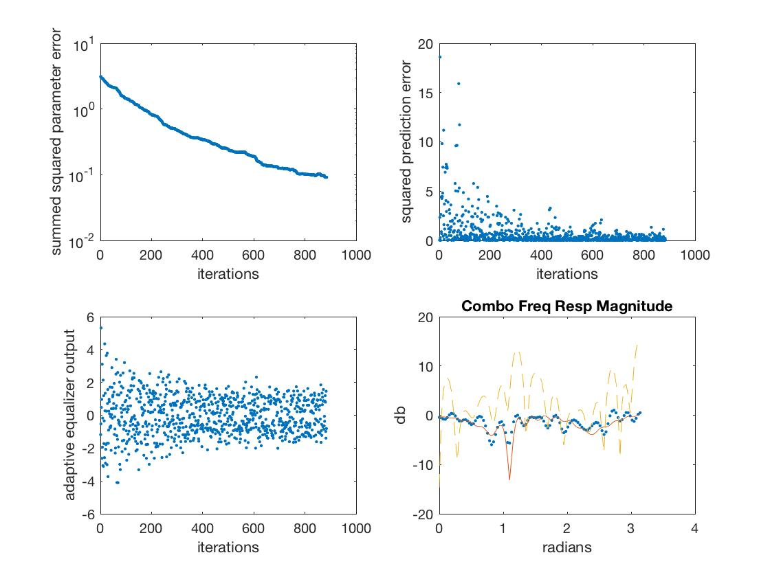

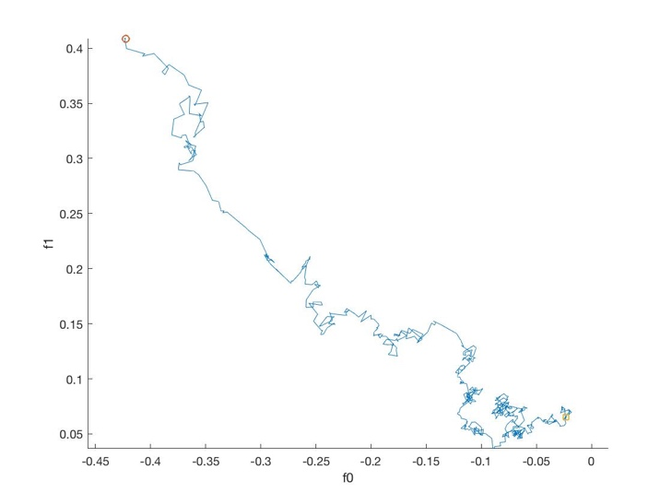

L12_2

For the time-varying channel, the MMSE method for 350-sample input has an error rate of 9.5%.